**Final Project Memo**

Zach Broomall

To: Dr. Thomas Craig

Date: May 2, 2022

Subject: Analysis of Median Household Income of Family Types 2013

**Overview**

Growing up can look very different for everyone. This ranges from having both parents or growing up with a single mother or father. With these different possibilities also come different types of financials. Most people know or are part of a family with a single parent and the way they grow up is different because in most cases they are forced to grow up faster. I am lucky enough to have both my parents while I was growing up so I did have those possible struggles to grow up faster then I had to. So it is important to look into the facts of how much different types of households make per year on average and try to put ourselves in their shoes.

**Statement of Hypothesis**

The data I have found from Status of Women in the States shows each state and their different avenger income for 6 different household types. This data is crazy to look at because in many cases the income is way below the standard of living today which is about $51,000 a year. Pictured below are the averages for each family type in the United States in 2013.



Null Hypothesis (H0): The average household income of Male Headed and Women Headed families with children are the same.

Alternative Hypothesis (H1): The average household income of Male Headed and Women Headed families with children are different.

**Data and Analysis Methodology**

The Status of Women in the States data that I gathered contains information on median household income of 6 different family categories in the year 2013. This data shows each state including The District of Columbia and the national average in the United States. This adds up to a total of 52 observations with 7 variables. I used Minitab to do my analysis and comparisons for this dataset. In Minitab I used the 1 sample t-test, 2 sample t-test and the Anova one way test with Tukey. I felt these were the appropriate tests to use for this data because they compare means of a sample population and compare groups.

**Results**

The first test I did was a 1 sample t test which compares the mean to a hypothesized mean of 30,155. I got this number from taking the average of the two national averages for single male and female with children. The p-value was 0 meaning we can take the alternative hypothesis because the p-value was less than 0.05 at a 95% confidence interval. Looking at the histogram of the two tests the hypothesized value was at the higher end of the female with children while it was at the lower end of the male with children.

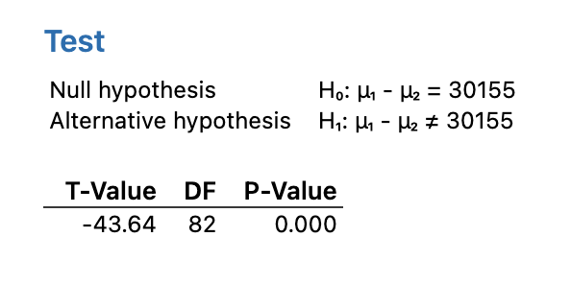

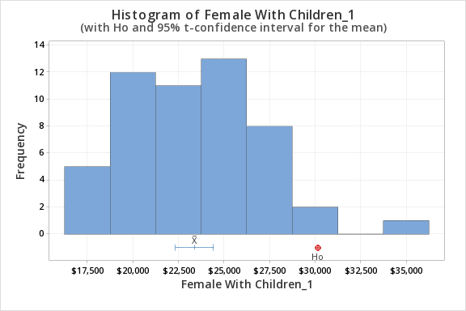

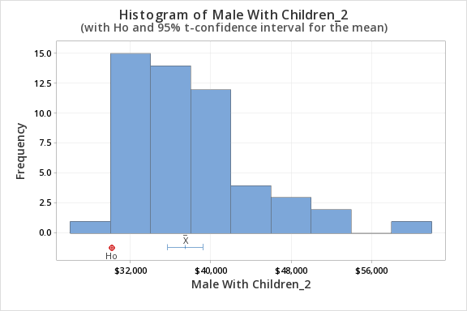

The 2 sample t test shows with a 95% confidence interval that the alternative hypothesis we can say is true. This is true because we see that the p-value is at a 0.0 indicating 0%. Looking at the individual value plot it is easy to see that males with children are significantly different from females with children. There are only a few points that overlap which is not enough for us to say that the null hypothesis is true.

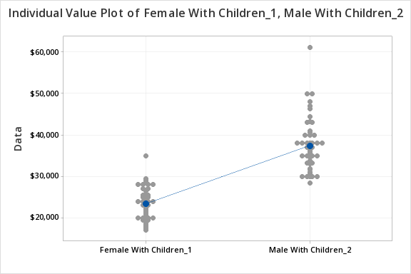

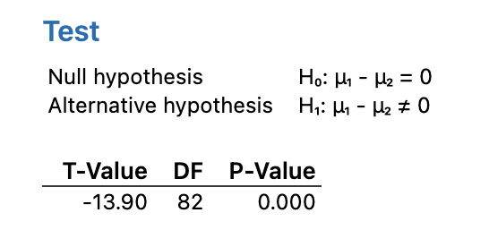

Using the Anova analysis I looked to see if there were any trends in which some data overlapped. In fact it did, whether you had children or not as a single parent you made almost the same amount. While if you were married with or without kids you made more money. With the numbers looking as they do, this analysis makes one believe that men are paid more than women. Also if you are married you make more money because there are two contributors to the household.

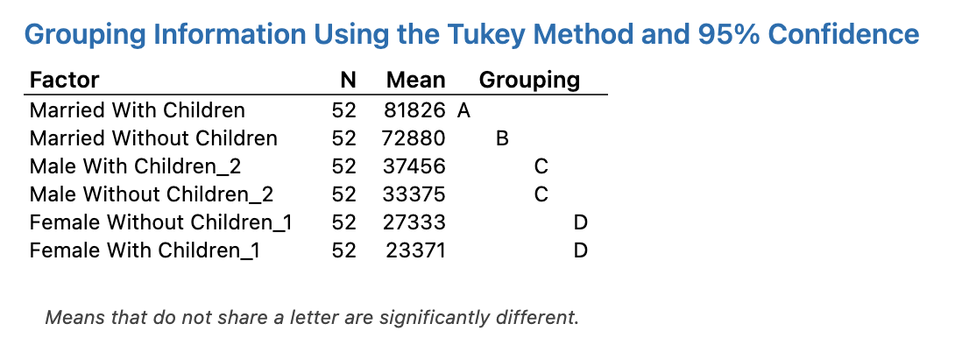

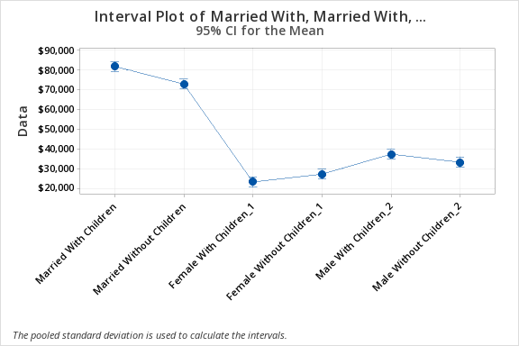

**Discussion and Conclusion**

After looking at the data crunched it was revealed that the alternative hypothesis led to be true that the average household income between men and women with children were different. In fact they were vastly different in that the averages for the two were a difference of about $13,000. There could be causes of that because this was data from 2013 and men made just under $11,000 more than women did that year. So as this pay gap has been getting better to where both men and women are paid equally I believe we will see a change as in the null hypothesis will become true.

Works Cited

*Pay Equity Information*, [www.pay-equity.org/info-time.html](http://www.pay-equity.org/info-time.html).

“Median Household Income by Household Type.” *Women in the States*, 29 July 2015, statusofwomendata.org/explore-the-data/poverty-opportunity/additional-state-data/median-household-income-by-household-type/.